

CS350 Safehome Project
Independent Testing

Team 1
20190813 Minjun Kim
20210145 Jehyung Kim
20210482 Onejune Lee
20210484 Yunje Lee

Table of Contents
I. Overview 2
1 Introduction 2
2. Goal 2
II. Bug Report 3
1. TEAM 2 3
Missing Implementations 3
Bugs 5
2. TEAM 3 7
Missing Implementations 7
Bugs 9
3. TEAM 4 11
Missing Implementations 11
Bugs 12
4. TEAM 5 17
Missing Implementations 17
Bugs 20
5. TEAM 6 25
Missing Implementations 25
Bugs 26
6. TEAM 7 31
Missing Implementations 31
Bugs 31
7. TEAM 8 34
Missing Implementations 34
Bugs 37
8. TEAM 9 39
Missing Implementations 39
Bugs 43
III. Who Did What 44
Appendix A. Glossary 45

I. Overview

1 Introduction
This document provides a system-level evaluation of the implementations submitted by Teams 2 through 9. Each team's program was executed and tested under realistic end-to-end usage scenarios to identify missing implementations, functional bugs, and deviations from the expected system behavior.
All detected issues were cross-checked against the original SRS (Software Requirements Specification) and SDS (Software Design Specification) to verify whether the implementation satisfies the functional and non-functional requirements defined in the project scope. By comparing the actual behavior with the intended design and requirements, this report highlights mismatches, omissions, and inconsistencies that must be addressed for full compliance.

2. Goal
The goal of this report is to systematically identify requirement-level gaps, missing implementations, and functional bugs across Teams 2–9, and to provide a clear comparison between the expected behavior (SRS/SDS) and the actual system behavior.

II. Bug Report

1. TEAM 2

Missing Implementations

Item | Security Page Login Retry Limit Not Enforced
Details | On the Security Page (2-level authentication), entering the wrong password more than 3 times does not trigger the required lockout behavior. The system continues to accept further attempts indefinitely, creating a brute-force vulnerability.
Reference | SRS: Use Case 'Log onto the system through web browser' - Exception 4a.2: If incorrect ID/password is entered 3 times, the system locks itself for predefined time
Tester | Jehyung Kim
Test Date | 2025-12-05

Item | Configuration Settings Default Reset Not Working
Details | The UI suggests default reset functionality, but SRS/SDS does not define reset behavior; feature appears not implemented.
Reference | Not defined in SRS/SDS - implicit usability requirement
Tester | Jehyung Kim
Test Date | 2025-12-06

Item | Missing Password Validation When Changing Web Password
Details | The system allows changing web password without double checking password. Validation logic is not implemented.
Reference | SRS: Use Case 'Configure system setting' - Step 5: password reconfirmation field required
Tester | Jehyung Kim
Test Date | 2025-12-05

Item | Missing Phone Number / Identity Verification in Security Page Access
Details | According to SRS, every security-critical action on the web interface must reconfirm the user's identity via address or phone number. The Security Page Access currently requires only the web password, omitting the required identity confirmation step.
Reference | SRS: Use Case 'Arm/disarm system through web browser' - Step 3: The homeowner enters address or phone number to reconfirm identity
Tester | Jehyung Kim
Test Date | 2025-12-04

Item | Missing Vertical (Up/Down) Pan Controls in Camera Viewer
Details | The Camera Viewer provides only left and right pan controls, but lacks required vertical (up/down) pan buttons. According to system requirements, cameras must support pan and zoom operations.
Reference | SRS: Use Case 'Pan/Zoom specific camera view' - Camera operations must allow pan and zoom; SDS: SafeHomeCamera class - panLeft(), panRight() methods
Tester | Jehyung Kim
Test Date | 2025-12-06

Item | Security Page Bypass: Sensor & Mode Access Without Reverification
Details | Users can access realtime sensor status and modify home modes directly through the Mode and Sensors menus without passing through the required Security Page. This allows unrestricted access, defeating the purpose of the Security Page.
Reference | SRS: Use Case 'Arm/disarm system through web browser' - Step 3: address/phone re-verification required; SDS: PhoneNumberValidationPage class
Tester | Jehyung Kim
Test Date | 2025-12-07

Item | Floor Plan Sensor Selection Not Supported in Redefine Security Mode
Details | In the 'Redefine Security Mode' page, clicking sensors on the Floor Plan does not toggle or select them. Users must modify sensors only via the side list, despite the UI suggesting interactive Floor Plan selection.
Reference | SRS: Use Case 'Configure SafeHome modes' - Step 8: The homeowner selects or deselects sensors on floor plan; SDS: FloorPlan class, DeviceIcon class
Tester | Jehyung Kim
Test Date | 2025-12-05

Item | Floor Plan Camera Icons Not Responding to Click
Details | In the Surveillance Floor Plan View, clicking camera icons produces no response. The expected behavior is that selecting a camera icon should initiate the 'Display Specific Camera View' flow.
Reference | SRS: Use Case 'Display Specific camera view' - Step 5: The homeowner selects a camera icon from the floor plan; SDS: Sequence Diagram 'Display Specific camera view', DeviceIcon class
Tester | Jehyung Kim
Test Date | 2025-12-04

Bugs

Item | Master Password Change Not Reflected
Details | Changing the master password through the Control Panel shows a success state, but the system continues to accept the old password. Indicates failure in updating stored credential or syncing with authentication subsystem.
Reference | SRS: Use Case 'Change master password through control panel' - Step 9: The system changes the master password; SDS: LoginManager class, StorageManager class
Reproduction Steps | 1. Open Control Panel UI  2. Login using current master password  3. Navigate to Change Password  4. Enter current → new → confirm new password  5. System displays 'password changed'  6. Logout and attempt login with new password → fails  7. Attempt login with old password → succeeds
Screenshot | 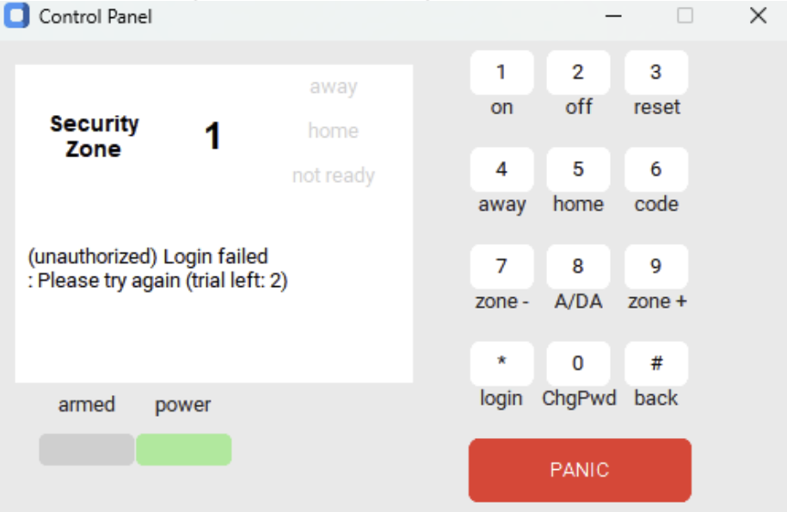
Tester | Jehyung Kim
Test Date | 2025-12-06

Item | Web Login Retry Limit Not Enforced
Details | Incorrect password attempts produce an error message, but the system never locks after 3 failures. Retry counter logic is present but not functioning.
Reference | SRS: Use Case 'Log onto the system through web browser' - Exception 4a.2: Lock system after 3 failed attempts; SDS: State Diagram for LoginManager
Reproduction Steps | 1. Open Web Login page  2. Enter wrong password 3+ times  3. Observe repeated 'incorrect password' messages  4. System never enters lock state  5. Immediately retry login without delay → system allows attempts
Screenshot | 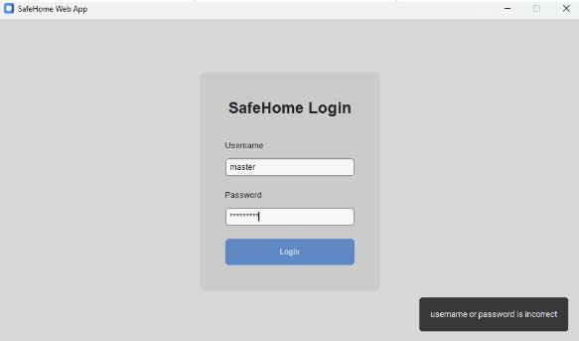
Tester | Jehyung Kim
Test Date | 2025-12-05

Item | System Lock Time Setting Not Applied
Details | Updating System Lock Time in configuration settings has no effect on actual lock duration. Control panel always uses a fixed internal lock period.
Reference | SRS: Use Case 'Configure system setting' - System lock time is a configurable parameter; SDS: SystemSettings class, State Diagram for SystemSettings
Reproduction Steps | 1. Open Web App → Configure  2. Change 'System Lock Time' to a different value  3. Save settings  4. Trigger lockout by login failure on Control Panel  5. Observe countdown shows fixed value rather than newly set duration
Screenshot | 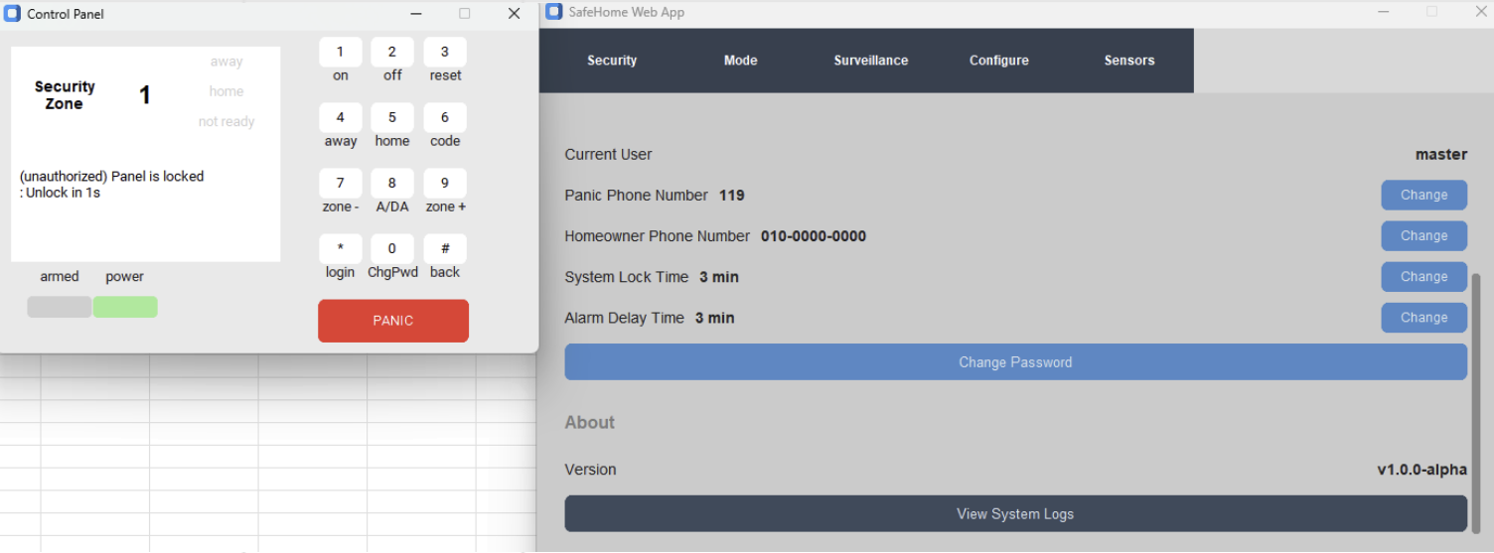
Tester | Jehyung Kim
Test Date | 2025-12-07

Item | Mode Change Not Synchronized Between Web Interface and Control Panel
Details | Changing SafeHome mode (Home/Away/Travel modes) on the Web Interface does not update the Control Panel. System state becomes inconsistent across interfaces.
Reference | SRS: Use Case 'Arm/disarm system through control panel' and 'Arm/disarm system through web browser' - Both interfaces must change the same system status; SDS: System class, SafeHomeMode class
Reproduction Steps | 1. Open Web SafeHome App → Navigate to Mode page  2. Click Set Away in Web  3. Observe: Control Panel still displays home
Screenshot | 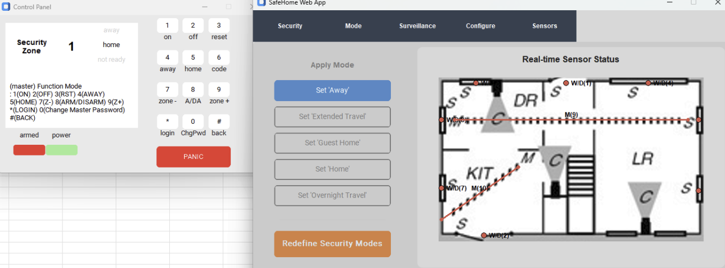
Tester | Jehyung Kim
Test Date | 2025-12-04

Item | Multiple Configuration Windows Opened by 'Redefine Security Modes'
Details | On the web interface, clicking 'Redefine Security Modes' opens a new configuration window without closing the existing one. Multiple overlapping configuration windows are created, confusing the user.
Reference | SRS: Use Case 'Configure SafeHome modes' - Single flow for editing modes; SDS: SafeHomeModeConfigurePage class, WebInterface class
Reproduction Steps | 1. Open SafeHome Web App → go to Mode page  2. Click 'Redefine Security Modes' once → Configuration window appears  3. Without closing it, click 'Redefine Security Modes' again  4. Observe: a second configuration window opens on top of the first  5. Repeat several times → multiple duplicate windows open
Screenshot | 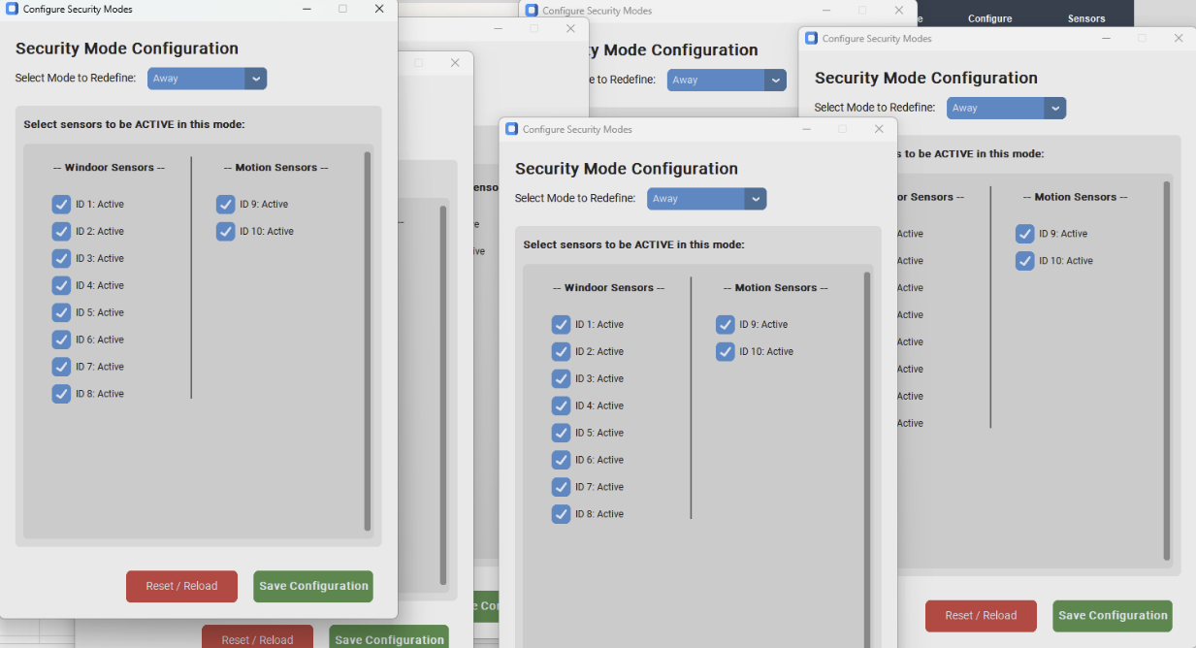
Tester | Jehyung Kim
Test Date | 2025-12-06

2. TEAM 3

Missing Implementations

Item | Incorrect Lockout Condition (Triggers on 4 Failed Attempts Instead of 3)
Details | The SRS states that the system must lock after three consecutive failed password attempts. However, the Control Panel implementation triggers lockout only after four failed attempts.
Reference | SRS: Use Case 'Log onto the system through control panel' - Exception 3a.2: If incorrect password entered three times in a row, system locks for predefined time
Tester | Jehyung Kim
Test Date | 2025-12-05

Item | Missing Zoom Level Limitation in Camera Viewer
Details | The camera viewer allows the user to zoom in more than five times without any upper limit. Users can continue zooming far beyond reasonable levels, resulting in distorted images.
Reference | SRS: Use Case 'Pan/Zoom specific camera view' - Camera zoom functionality; SDS: SafeHomeCamera class - zoomIn(), zoomOut() methods
Tester | Jehyung Kim
Test Date | 2025-12-06

Item | Missing Vertical Pan (Up/Down) Controls in Camera Viewer
Details | The camera viewer provides left and right pan controls but does not include vertical (up/down) pan buttons. The absence of vertical pan controls indicates partial implementation.
Reference | SRS: Use Case 'Pan/Zoom specific camera view' - Step 2: Press 'L' or 'R' to pan; SDS: SafeHomeCamera class pan methods
Tester | Jehyung Kim
Test Date | 2025-12-04

Item | Thumbnail View Camera Click Not Working
Details | In the thumbnail view, clicking on camera thumbnails does not navigate to the individual camera view or respond to user interaction.
Reference | SRS: Use Case 'View thumbnail Shots' and 'Display Specific camera view' - Camera selection from thumbnail; SDS: ThumbnailViewPage class, CameraController class
Tester | Jehyung Kim
Test Date | 2025-12-07

Item | Configuration Settings Default Reset Not Working
Details | The UI suggests default reset functionality, but SRS/SDS does not define reset behavior; feature appears not implemented.
Reference | Not defined in SRS/SDS - implicit usability requirement
Tester | Jehyung Kim
Test Date | 2025-12-05

Item | Missing Ability to Cancel Password Change on Control Panel
Details | During the password change process on the Control Panel, the user cannot cancel or exit the flow once it begins. The interface does not provide a Cancel or Back option.
Reference | SRS: Use Case 'Change master password through control panel' - No explicit cancel requirement but essential UI flow; SDS: State Diagram for LoginInterface
Tester | Jehyung Kim
Test Date | 2025-12-06

Bugs

Item | Lock Time Countdown Not Progressing After Lockout
Details | After triggering lockout due to multiple failed password attempts, the Control Panel displays 'Lock time left: XXX seconds.' However, the countdown in UI shows no progress - time does not decrease.
Reference | SRS: Use Case 'Log onto the system through control panel' - Exception 3a.2: System locks for predefined time; SDS: State Diagram for LoginManager
Reproduction Steps | 1. Launch the Control Panel  2. Enter an incorrect password several times to trigger lockout  3. Observe the displayed 'Lock time left: N seconds'  4. Wait and confirm that the value does not decrease
Screenshot | 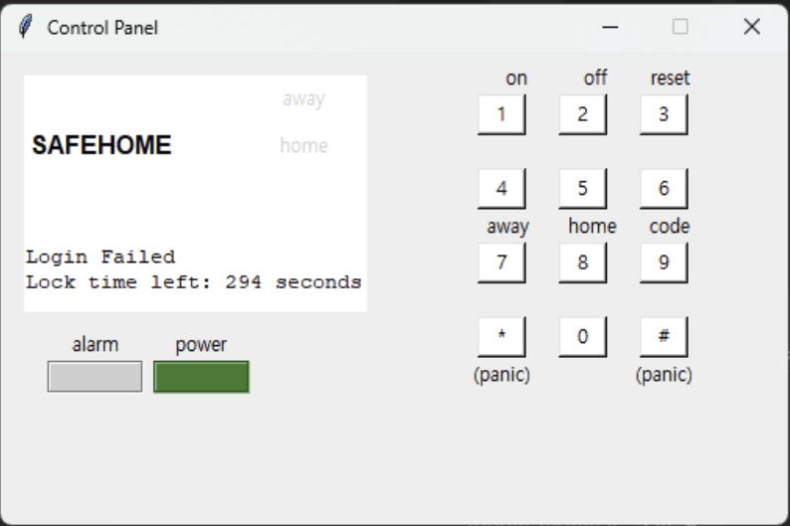
Tester | Jehyung Kim
Test Date | 2025-12-05

Item | Camera Status Inconsistent Across UI Components
Details | Camera 1 requires a password (locked). After entering the password and disabling the camera, navigating back shows conflicting states: Camera Status panel shows 'Disabled' while Thumbnail View shows 'Locked'.
Reference | SRS: Use Case 'Display Specific camera view' - Consistent camera access restrictions; SDS: SafeHomeCamera class, State Diagram for SafeHomeCamera
Reproduction Steps | 1. Open the Surveillance page  2. Select Camera 1 and enter the password to unlock it  3. Disable the camera  4. Navigate away and return to Surveillance page  5. Observe: Camera Status panel → 'Disabled', but Thumbnail View → 'LOCKED'
Screenshot | 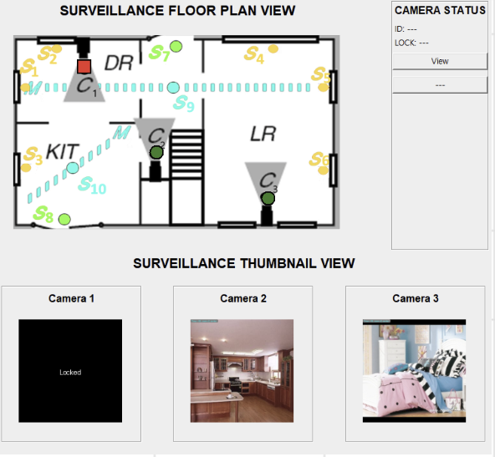
Tester | Jehyung Kim
Test Date | 2025-12-07

Item | System Lock Time Not Applying After Update
Details | When the user updates the System Lock Time to 10 seconds, the updated value is displayed but not applied. The Control Panel continues using the previous lock time (300 seconds).
Reference | SRS: Use Case 'Configure system setting' - System lock time configuration; SDS: SystemSettings class, StorageManager class
Reproduction Steps | 1. Open Web App → Navigate to Configuration page  2. Set System Lock Time = 10 seconds and click SAVE  3. Trigger lockout by login failure on Control Panel  4. Observe: Control Panel displays 'Lock time left: 300 seconds' (old value)
Screenshot | 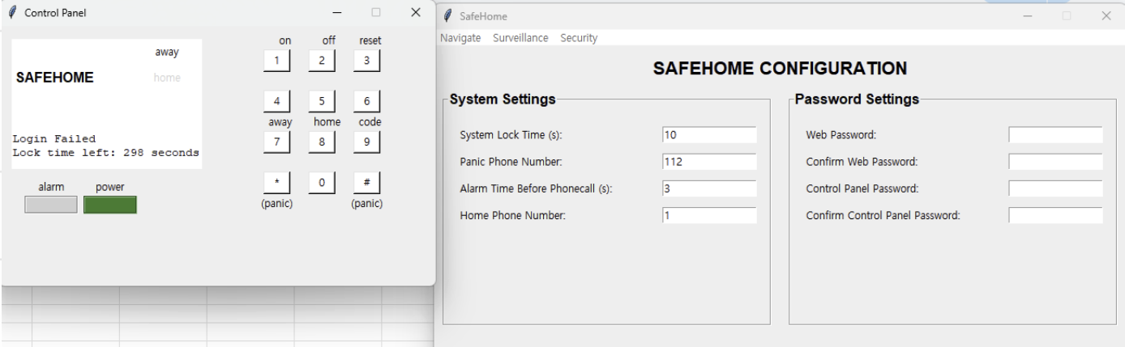
Tester | Jehyung Kim
Test Date | 2025-12-04

Item | Mode Change Not Synchronized Between Control Panel and Web Interface
Details | When the Web Interface is set to 'Extended' mode and the user selects 'Away' on the Control Panel, the Web Interface does not update. This causes conflicting mode states.
Reference | SRS: Use Case 'Arm/disarm system through control panel' and 'Arm/disarm system through web browser'; SDS: System class, SafeHomeMode class, State Diagram for SafeHomeMode
Reproduction Steps | 1. Open Web Interface → Select Extended mode  2. Open Control Panel → Press Away  3. Observe: Control Panel enters Away mode successfully  4. Check Web Interface → Still displays Extended, not Away
Screenshot | 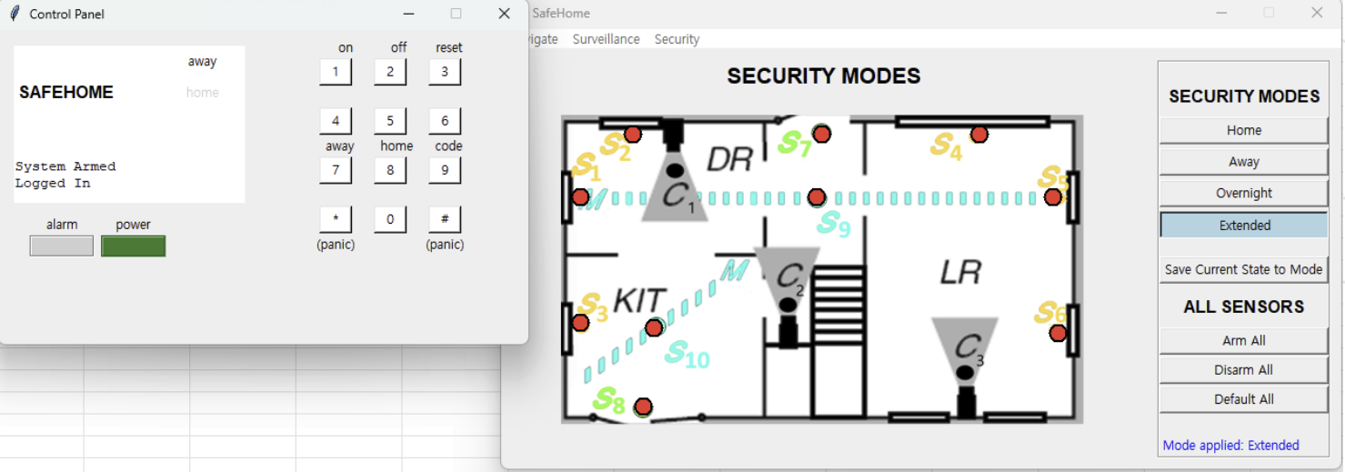
Tester | Jehyung Kim
Test Date | 2025-12-06

Item | Home Mode Overwritten by Security Zone Changes Without Saving
Details | After adjusting sensor activations in the Security Zone screen, returning to Security Mode page and selecting 'Home' causes the Home mode's sensor configuration to change without pressing 'Save Current State to Mode'.
Reference | SRS: Use Case 'Configure SafeHome modes' - Each mode must maintain its own predefined active sensor set; SDS: SafeHomeMode class, SafetyZone class
Reproduction Steps | 1. Open Security Mode screen → Select Home mode  2. Switch to Security Zone and modify some sensors  3. Return to Security Mode page  4. Click Home again  5. Observe: Home mode reflects temporary sensor configuration without save
Screenshot | 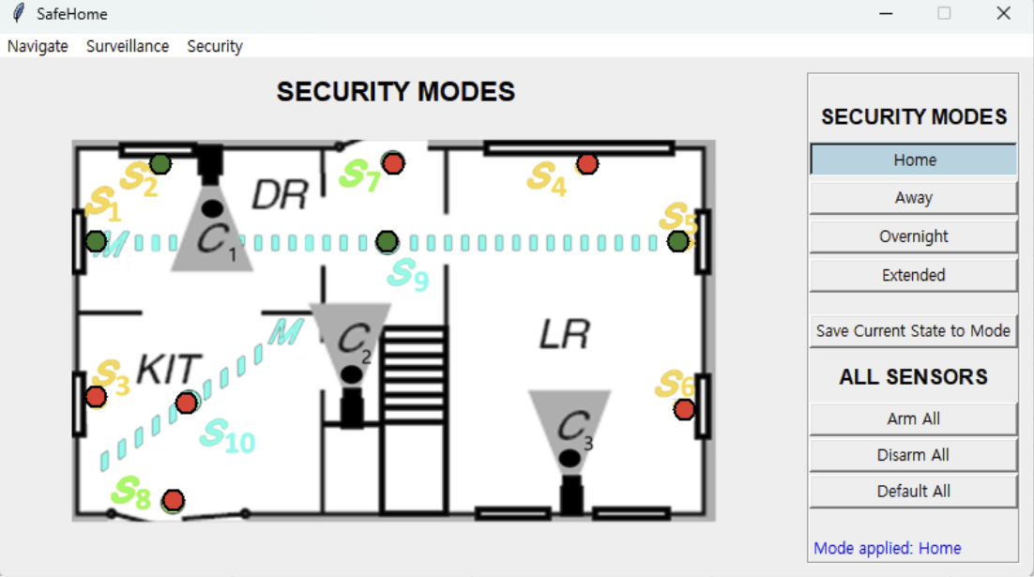
Tester | Jehyung Kim
Test Date | 2025-12-05

3. TEAM 4

Missing Implementations

Item | Vertical Pan Function for Camera
Details | Camera can only pan horizontally. Vertical pan function is not available.
Reference | SRS: Use Case 'Pan/Zoom specific camera view' - Camera Control Requirements; SDS: Sequence Diagram 'Pan/Zoom specific camera view', SafeHomeCamera class
Tester | Minjun Kim
Test Date | 2025-12-04

Item | Zone Regeneration Function
Details | Unable to regenerate zone. Returns 'Resource not found' error when attempting to regenerate zones.
Reference | SRS: Use Case 'Configure safety zone', 'Create new safety zone', 'Delete safety zone', 'Update an exist safety zone'; SDS: Sequence Diagrams for Safety Zone Management
Tester | Minjun Kim
Test Date | 2025-12-05

Item | Travel Mode Feature
Details | Travel mode functionality is not working. Users cannot activate or utilize travel mode as specified.
Reference | SRS: Use Case 'Arm/disarm system through web browser' - modes: home, away, overnight travel, extended travel; SDS: SafeHomeMode class, Sequence Diagram 'Configure SafeHome modes'
Tester | Minjun Kim
Test Date | 2025-12-06

Item | Overall User Preference Functions
Details | User preference management functions are missing. Cannot configure or save user-specific settings.
Reference | SRS: Use Case 'Configure system setting' - delay time, passwords, phone number configuration; SDS: Sequence Diagram 'Configure system setting', SystemSettings class
Tester | Minjun Kim
Test Date | 2025-12-07

Item | Numeric Range Limits Validation
Details | No validation for numeric input ranges. System accepts invalid numeric values without boundary checking.
Reference | SRS: Use Case 'Configure system setting' - Exception 6b: delay time must be at least 5 minutes; Defensive Programming Standards
Tester | Minjun Kim
Test Date | 2025-12-04

Item | String Maximum Length Validation
Details | No maximum length constraints on string inputs. Could lead to buffer overflow or database issues.
Reference | SRS: Use Case 'Log onto the system through control panel' - 4-digit password constraint; Input Validation Requirements
Tester | Minjun Kim
Test Date | 2025-12-05

Item | Formal Test Plan Documentation
Details | No formal test plan exists. Testing strategy, scope definition, and integration strategy are not documented.
Reference | Project Plan: Testing & bug fixing phase; Quality Assurance Requirements
Tester | Minjun Kim
Test Date | 2025-12-06

Item | Requirements Traceability Matrix
Details | No traceability matrix linking tests to SRS requirements. Cannot verify complete requirement coverage.
Reference | SRS: All Use Cases; SDS: Design traceability to requirements; Quality Assurance Requirements
Tester | Minjun Kim
Test Date | 2025-12-07

Bugs

Item | Hardcoded SECRET_KEY Security Vulnerability
Details | SECRET_KEY is hardcoded as 'a_very_secret_key' in authentication.py:15. This makes JWT tokens forgeable by anyone with code access. The secret key should be stored in environment variables.
Reference | SRS: Use Case 'Log onto the system through control panel' - Password authentication requirements; Non-Functional Requirements: Security
Reproduction Steps | 1. Review authentication.py source code  2. Locate SECRET_KEY variable at line 15  3. Observe hardcoded value 'a_very_secret_key'  4. Security vulnerability confirmed
Screenshot | No image
Tester | Minjun Kim
Test Date | 2025-12-05

Item | Missing Dependencies in requirements.txt
Details | CRITICAL dependencies python-dotenv and python-multipart are missing from requirements.txt. Tests fail immediately after cloning with ModuleNotFoundError.
Reference | Project Plan: Construction & testing phase; Development Environment Setup Requirements
Reproduction Steps | 1. Clone repository  2. Run pip install -r requirements.txt  3. Attempt to run tests  4. Observe ModuleNotFoundError for python-dotenv and python-multipart
Screenshot | No image
Tester | Minjun Kim
Test Date | 2025-12-04

Item | Korean Comments in English Codebase
Details | Korean comments and docstrings found in test_login_usecase.py:36-38 and authentication.py:24-28. This violates international coding standards and makes code unmaintainable.
Reference | International Coding Standards; Code Maintainability Requirements
Reproduction Steps | 1. Open test_login_usecase.py  2. Navigate to lines 36-38  3. Observe Korean language comments  4. Check authentication.py lines 24-28 for same issue
Screenshot | No image
Tester | Minjun Kim
Test Date | 2025-12-06

Item | 102 Print Statements in Production Code
Details | 102 print() statements found throughout production code. These should be replaced with proper logging framework. Print statements can expose sensitive information.
Reference | Implementation: Style Guide Compliance; Best Practices: Logging Standards
Reproduction Steps | 1. Run grep -r 'print(' on codebase  2. Count occurrences: 102 print statements found  3. Review sensitive data exposure risk
Screenshot | No image
Tester | Minjun Kim
Test Date | 2025-12-07

Item | 17 Bare Except Clauses
Details | 17 bare 'except:' clauses found in code. These catch ALL exceptions including KeyboardInterrupt and SystemExit, making debugging impossible.
Reference | Python Exception Handling Best Practices; SDS: Design Goal - reliability and maintainability
Reproduction Steps | 1. Run grep -r 'except:' on codebase  2. Count occurrences: 17 bare except clauses found  3. Review error handling patterns
Screenshot | No image
Tester | Minjun Kim
Test Date | 2025-12-04

Item | Password Validation Not Working
Details | 4-digit password validation check is not functioning. System accepts passwords with even one digit. Password entry trial doesn't lock after three wrong attempts.
Reference | SRS: Use Case 'Log onto the system through control panel' - 4-digit password requirement, Exception 3a.2; SDS: LoginManager class
Reproduction Steps | 1. Access password change functionality  2. Enter single digit password  3. Observe system accepts invalid password  4. Test lockout by entering wrong password 3+ times  5. Observe no lockout triggered
Screenshot | No image
Tester | Minjun Kim
Test Date | 2025-12-05

Item | Armed/Power Button Not Working on Panel GUI
Details | Armed button and power button on panel GUI are non-functional. Users cannot arm the system or control power through the GUI interface.
Reference | SRS: Use Case 'Turn the system on', 'Turn the system off', 'Arm/disarm system through control panel'; SDS: Sequence Diagrams for system power and arm/disarm
Reproduction Steps | 1. Open Control Panel GUI  2. Click Armed button  3. Observe no response  4. Click Power button  5. Observe no response
Screenshot | No image
Tester | Minjun Kim
Test Date | 2025-12-06

Item | Default Admin Account Never Expires
Details | Default admin account (root:0000) created at startup.py:23-28 never expires. This permanent privileged account is a security vulnerability.
Reference | SRS: Use Case 'Log onto the system through control panel' - Security Requirements; Non-Functional Requirements: Security
Reproduction Steps | 1. Review startup.py source code  2. Locate lines 23-28  3. Observe default admin account creation  4. Verify no expiration mechanism exists
Screenshot | No image
Tester | Minjun Kim
Test Date | 2025-12-07

Item | Sensor Status Not Working in Testing Phase
Details | Sensor status reporting is not functioning correctly during testing phase. Sensors do not report their actual status to the system.
Reference | SRS: Use Case 'Alarm condition encountered' - Sensor detection mechanism; SDS: Sensor class, SensorController class, State Diagram for Sensor
Reproduction Steps | 1. Run system in test mode  2. Simulate sensor trigger  3. Observe sensor status not updating  4. Check system logs for sensor events
Screenshot | No image
Tester | Minjun Kim
Test Date | 2025-12-04

Item | Wrong Alarm Activation (Door 8 for Door 1)
Details | When modifying door 1, alarm for door 8 is activated instead. This is a severe logic error that could compromise security.
Reference | SRS: Use Case 'Alarm condition encountered' - Sensor identification and event reporting; SDS: Sequence Diagram 'Alarm condition encountered', Sensor class
Reproduction Steps | 1. Access door sensor configuration  2. Modify door 1 sensor  3. Observe alarm triggered for door 8 instead  4. Verify sensor ID mapping error
Screenshot | No image
Tester | Minjun Kim
Test Date | 2025-12-05

Item | Camera View UI Cut-off
Details | User interface is cut off at the camera view, specifically the 'zoom in' button is not fully visible or accessible.
Reference | SRS: Use Case 'Pan/Zoom specific camera view' - Camera Controls; UI Design Requirements
Reproduction Steps | 1. Open camera view page  2. Observe zoom in button partially hidden  3. Attempt to click zoom in  4. Button not fully accessible
Screenshot | No image
Tester | Minjun Kim
Test Date | 2025-12-06

Item | Un-clickable Floor Plan
Details | Floor plan interface is un-clickable. Users cannot interact with the floor plan to select zones or view sensor locations.
Reference | SRS: Use Case 'Configure safety zone', 'Create new safety zone' - Floor plan interaction; SDS: FloorPlan class, DeviceIcon class
Reproduction Steps | 1. Navigate to floor plan view  2. Attempt to click on zones  3. Observe no response  4. Attempt to click on sensor locations  5. Observe no response
Screenshot | No image
Tester | Minjun Kim
Test Date | 2025-12-07

Item | Missing Test Dependencies Block E2E Tests
Details | Missing python-multipart and python-dotenv dependencies block End-to-End tests. Files test_auth_e2e.py and test_camera_router.py cannot be executed.
Reference | Testing: Environment & Tools; Test Coverage Impact
Reproduction Steps | 1. Attempt to run E2E tests  2. Observe collection errors for test_auth_e2e.py  3. Observe collection errors for test_camera_router.py  4. Tests cannot execute due to missing dependencies
Screenshot | No image
Tester | Minjun Kim
Test Date | 2025-12-04

Item | Test Coverage Cannot Be Verified
Details | Coverage report FAILED due to E2E collection errors. Actual coverage is estimated at 60-70% but cannot be verified. Frontend tests were NOT EXECUTED.
Reference | Testing: Test Coverage; Quality Metrics: Coverage Verification
Reproduction Steps | 1. Run pytest with coverage  2. Observe E2E collection errors  3. Coverage report incomplete  4. Frontend tests skipped
Screenshot | No image
Tester | Minjun Kim
Test Date | 2025-12-05

Item | Admin Signup Test Failed
Details | test_admin_signup_successfully test case FAILED. New admin accounts cannot be created through the signup process.
Reference | Test File: test_admin_signup_successfully; Functional Requirements: User Management
Reproduction Steps | 1. Run pytest test_admin_signup_successfully  2. Observe test failure  3. Admin signup functionality broken
Screenshot | No image
Tester | Minjun Kim
Test Date | 2025-12-06

4. TEAM 5

Missing Implementations

Item | Database Persistence - Complete Data Loss on Restart
Details | No database implementation. UserDB.users=[] stored only in memory. ALL user data, safety zones, alarm events, and configuration changes are LOST ON SERVER RESTART.
Reference | SRS: Use Case 'Configure system setting' - System configuration persistence; Non-Functional Requirements: Reliability; SDS: StorageManager class
Tester | Minjun Kim
Test Date | 2025-12-04

Item | Password Change Functionality Broken
Details | Password change API returns success status but does NOT actually update passwords. The config API accepts password change requests but fails to persist changes.
Reference | SRS: Use Case 'Change master password through control panel' - Step 9: System changes password; SDS: Sequence Diagram 'Change master password through control panel', LoginManager class
Tester | Minjun Kim
Test Date | 2025-12-05

Item | Delay Time Logic Not Implemented
Details | Delay time is accepted in configuration but NOT actually executed. Code only appends a message but does not implement the actual delayed execution of monitoring service calls.
Reference | SRS: Use Case 'Alarm condition encountered' - Step 5: After delaying time, system dials monitoring service; SDS: System class, Alarm class
Tester | Minjun Kim
Test Date | 2025-12-06

Item | Actual Door/Window Sensor State Not Checked
Details | System uses dummy variable user.doors_windows_closed (always True) instead of checking actual sensor states. The windoor sensor's is_opened field is completely ignored.
Reference | SRS: Use Case 'Arm/disarm safety zone selectively' - Exception 7a: doors and windows must be closed; SDS: SensorController class, WindowDoorSensor class
Tester | Minjun Kim
Test Date | 2025-12-07

Item | Alarm Audio/Visual Output Not Implemented
Details | Alarm activation only creates log messages. No actual audible alarm sound or LED control is implemented. System claims 'Audible alarm activated' but this is only a string message.
Reference | SRS: Use Case 'Alarm condition encountered' - Step 3: System invokes audible alarm; SDS: Alarm class, State Diagram for Alarm
Tester | Minjun Kim
Test Date | 2025-12-04

Item | Login Attempt Lockout Not Implemented
Details | No login attempt limiting despite user.login_attempts field existing. System allows unlimited login attempts with no account lockout, enabling brute force attacks.
Reference | SRS: Use Case 'Log onto the system through control panel' - Exception 3a.2: Lock system after 3 failed attempts; SDS: State Diagram for LoginManager
Tester | Minjun Kim
Test Date | 2025-12-05

Item | Input Length Validation Missing
Details | No maximum length limits on string inputs. System accepts 100MB passwords, unlimited device names, and unbounded delay_time values. This enables memory exhaustion attacks.
Reference | Implementation: Input Validation; Non-Functional Requirements: Resource Protection; Security: DoS Prevention
Tester | Minjun Kim
Test Date | 2025-12-06

Item | Partial Update Configuration Not Supported
Details | Config API requires ALL fields to be sent even for single field updates. Cannot do partial updates, forcing clients to always send complete configuration including passwords.
Reference | API: /config/ endpoint; RESTful API Best Practices
Tester | Minjun Kim
Test Date | 2025-12-07

Item | Multi-User Support Not Implemented
Details | System hardcodes DEFAULT_USER_ID = 'homeowner1' for all surveillance operations. Cannot support multiple users simultaneously.
Reference | SRS: Primary actors - Homeowner, Guest; Use Case 'Log onto the system through control panel' - Master vs Guest password; SDS: LoginInterface class
Tester | Minjun Kim
Test Date | 2025-12-04

Item | Requirements Traceability Matrix Missing
Details | No formal traceability matrix linking tests to SRS requirements. While integration tests have UC references in docstrings, there is no comprehensive mapping document.
Reference | SRS: All Use Cases; SDS: Design traceability; Quality Assurance: Requirements Coverage
Tester | Minjun Kim
Test Date | 2025-12-05

Bugs

Item | Plaintext Password Storage - CATASTROPHIC Security Vulnerability
Details | All passwords stored in plaintext in source code and memory. user.py:77-80 contains hardcoded passwords. No password hashing (bcrypt, argon2) implemented.
Reference | SRS: Use Case 'Log onto the system through control panel', 'Change master password through control panel' - Password validation; Non-Functional Requirements: Security
Reproduction Steps | 1. Review user.py source code  2. Navigate to lines 77-80  3. Observe plaintext passwords: '12345678', 'abcdefgh', '1234', '5678'  4. Verify no hashing mechanism exists
Screenshot | No image
Tester | Minjun Kim
Test Date | 2025-12-06

Item | Password Exposure via GET API - CATASTROPHIC
Details | GET /config/ endpoint returns ALL passwords (password1, password2, master_password, guest_password) in plain text in API responses.
Reference | SRS: Use Case 'Configure system setting' - Password management; Non-Functional Requirements: Security; SDS: SystemSettings class
Reproduction Steps | 1. Login to system  2. Call GET /config/ endpoint  3. Observe all passwords returned in plaintext  4. Security vulnerability confirmed
Screenshot | No image
Tester | Minjun Kim
Test Date | 2025-12-07

Item | No Authentication/Authorization - CATASTROPHIC
Details | No authentication or authorization mechanism exists. No JWT tokens, no session management, no API keys. Anyone can call any API endpoint without proving identity.
Reference | Implementation: Authentication System; Security Requirements: Access Control
Reproduction Steps | 1. Access API endpoints without login  2. Observe all endpoints accessible  3. No authentication required  4. Complete security bypass possible
Screenshot | No image
Tester | Minjun Kim
Test Date | 2025-12-04

Item | Timing Attack Vulnerability in Login
Details | Password comparison uses == operator allowing timing attacks. Attackers can determine password content through response time analysis. Should use constant-time comparison.
Reference | SRS: Use Case 'Log onto the system through control panel' - Password validation; Security Best Practices: Constant-time comparison
Reproduction Steps | 1. Review common.py line 39  2. Observe: if request.password == user.master_password  3. Standard string comparison vulnerable to timing attacks  4. No constant-time comparison used
Screenshot | No image
Tester | Minjun Kim
Test Date | 2025-12-05

Item | God Object Anti-Pattern - surveillance.py
Details | surveillance.py contains 1144 lines (11.4% of entire codebase). This massive file violates Single Responsibility Principle and makes code unmaintainable.
Reference | SDS: Design Goal - low coupling, high cohesion, minimize complexity; CK Metrics
Reproduction Steps | 1. Count lines in surveillance.py: 1144 lines  2. Calculate percentage of codebase: 11.4%  3. Review responsibilities - too many in single file  4. Single Responsibility Principle violated
Screenshot | No image
Tester | Minjun Kim
Test Date | 2025-12-06

Item | 56 Print Statements Instead of Logging
Details | 56 print() statements used throughout production code instead of proper logging framework. This exposes sensitive information in console output.
Reference | Production Code Quality Standards; Logging Best Practices
Reproduction Steps | 1. Run grep -r 'print(' on codebase  2. Count occurrences: 56 print statements found  3. Review for sensitive data exposure
Screenshot | No image
Tester | Minjun Kim
Test Date | 2025-12-07

Item | Device ID Mismatch and Conflicts
Details | Dictionary keys (7, 8) don't match sensor_id values (1, 2) in windoor_sensors. Additionally, sensor_id=1 is used for both motion sensor and door sensor, causing ID collisions.
Reference | SRS: Use Case 'Alarm condition encountered' - Sensor identification; SDS: Sensor class hierarchy; Data Integrity Requirements
Reproduction Steps | 1. Review sensor configuration code  2. Observe dictionary keys 7, 8 with sensor_id 1, 2  3. Verify sensor_id=1 used for multiple sensor types  4. ID collision confirmed
Screenshot | No image
Tester | Minjun Kim
Test Date | 2025-12-04

Item | GET Request with Request Body - HTTP Violation
Details | /config/ endpoint uses @router.get() but accepts Request Body. This violates HTTP specification where GET should use query parameters only.
Reference | HTTP/1.1 Specification: RFC 7231; RESTful API Design Principles
Reproduction Steps | 1. Review common.py lines 133-134  2. Observe @router.get() with request body  3. HTTP GET should not have request body  4. Will fail with some HTTP clients
Screenshot | No image
Tester | Minjun Kim
Test Date | 2025-12-05

Item | Validation Error: Delay Time Documentation Mismatch
Details | Code checks delay_time >= 0 but error message says 'must be at least 300'. Documentation states 300 seconds minimum but implementation allows 0.
Reference | SRS: Use Case 'Configure system setting' - Exception 6b: delay time minimum 5 minutes (300 seconds); API Documentation consistency
Reproduction Steps | 1. Review delay time validation code  2. Observe: check for >= 0  3. Error message states minimum 300  4. SRS requires minimum 5 minutes (300 seconds)  5. Inconsistency between code, message, and SRS
Screenshot | No image
Tester | Minjun Kim
Test Date | 2025-12-06

Item | SafeHome Mode Validation Missing
Details | configure_safehome_modes() does not check for duplicate device_ids, does not verify if devices already assigned to other modes, and does not validate mode-specific constraints.
Reference | SRS: Use Case 'Configure SafeHome modes' - Mode configuration; SDS: Sequence Diagram 'Configure SafeHome modes', SafeHomeMode class
Reproduction Steps | 1. Call configure_safehome_modes with duplicate device_ids  2. Observe no validation error  3. Assign same device to multiple modes  4. No conflict detection
Screenshot | No image
Tester | Minjun Kim
Test Date | 2025-12-07

Item | Race Conditions in Concurrent Access
Details | CameraDB, SensorDB, UserDB have no thread synchronization. While camera_instances has a lock, the main data stores lack concurrency control.
Reference | Non-Functional Requirements: Reliability; SDS: Design Goal - reliability; Concurrency Control Requirements
Reproduction Steps | 1. Review database class implementations  2. Observe no threading locks on CameraDB, SensorDB, UserDB  3. Concurrent access will cause race conditions
Screenshot | No image
Tester | Minjun Kim
Test Date | 2025-12-04

Item | Camera PTZ Error Handling Incomplete
Details | When pan/tilt/zoom operations fail (success=False), system continues operation without notifying user of partial success or failure reasons.
Reference | SRS: Use Case 'Pan/Zoom specific camera view' - Error handling; SDS: SafeHomeCamera class methods
Reproduction Steps | 1. Trigger camera PTZ operation that fails  2. Observe success=False returned  3. System continues without user notification  4. User unaware of failure
Screenshot | No image
Tester | Minjun Kim
Test Date | 2025-12-05

Item | Null Check Missing in Database Queries
Details | CameraInfo.get_camera() returns None when camera not found, but calling code does not consistently check for None, potentially causing errors.
Reference | Defensive Programming Requirements; SDS: Design Goal - testability and reliability
Reproduction Steps | 1. Call get_camera() with non-existent ID  2. None returned  3. Calling code attempts to use None  4. Potential NullPointerException equivalent
Screenshot | No image
Tester | Minjun Kim
Test Date | 2025-12-06

Item | Frontend and Integration Tests Not Executable
Details | 0 integration tests run due to tkinter ModuleNotFoundError. 0 frontend tests run (10 files failed collection). Backend coverage 99%, but actual SYSTEM coverage only ~30%.
Reference | Project Plan: Testing & bug fixing phase; SRS: Use Cases requiring GUI testing
Reproduction Steps | 1. Run integration tests  2. Observe tkinter ModuleNotFoundError  3. 10 frontend test files fail collection  4. Actual system coverage severely limited
Screenshot | No image
Tester | Minjun Kim
Test Date | 2025-12-07

Item | pytest Not Installed by Default
Details | pytest is NOT INSTALLED initially, causing ModuleNotFoundError. This blocks immediate testing after clone.
Reference | Environment Setup; Dependency Management
Reproduction Steps | 1. Clone repository  2. Attempt to run pytest  3. ModuleNotFoundError: No module named 'pytest'  4. Testing blocked
Screenshot | No image
Tester | Minjun Kim
Test Date | 2025-12-04

Item | Empty Test Functions - UC2.d and UC2.e
Details | test_uc_2d() and test_uc_2e() functions exist but contain only 'pass' statement. Critical use cases for alarm conditions and safety zone configuration are not tested.
Reference | SRS: Use Case 'Alarm condition encountered' (UC2.d), Use Case 'Configure safety zone' (UC2.e); Test Coverage Requirements
Reproduction Steps | 1. Review test files  2. Locate test_uc_2d() and test_uc_2e()  3. Observe only 'pass' statement in each  4. Critical functionality untested
Screenshot | No image
Tester | Minjun Kim
Test Date | 2025-12-05

5. TEAM 6

Missing Implementations

Item | Web Password Change Function Missing
Details | Cannot change web password (master/guest) from web interface. System settings page exists but password modification fields not available.
Reference | SRS: Use Case 'Configure system setting' - Managing two web passwords (master/guest); SDS: Configuration and Data Management Architecture, SystemSettings class, Sequence Diagram 'Configure system setting'
Tester | Yunje Lee
Test Date | 2025-12-06

Item | Logout Function Missing
Details | No logout button or menu available in web or control panel interface. Must close browser to end session. No way to explicitly log out once logged in.
Reference | SRS: Use Case 'Log onto the system through control panel', 'Log onto the system through web browser' - Exception mentions logout; SDS: State Diagram for LoginInterface, State Diagram for LoginManager
Tester | Yunje Lee
Test Date | 2025-12-07

Item | Camera Floor Plan Not Implemented
Details | Camera selection only available through list view. Floor plan with camera icons for visual selection not implemented. Cannot select cameras by clicking on floor plan.
Reference | SRS: Use Case 'Display Specific camera view' - Select via camera icons on floor plan; Use Case 'Enable camera', 'Disable camera' via floor plan; SDS: FloorPlan class, DeviceIcon class, CameraPage class
Tester | Yunje Lee
Test Date | 2025-12-04

Item | Password Fields Missing in System Settings
Details | System settings page accessible but web master/guest password fields not present. Only shows delay time and phone number fields.
Reference | SRS: Use Case 'Configure system setting' - Including two web passwords, delay time, phone numbers; SDS: SystemSettings class, ConfigureSystemSettingPage class
Tester | Yunje Lee
Test Date | 2025-12-05

Bugs

Item | Armed Status Not Displayed
Details | After arming system via Home or Away button, no visual indicator (red/green light or text) shows whether system is armed or disarmed. User cannot determine current system status.
Reference | SRS: Use Case 'Arm/disarm system through control panel' - Step 4: red light for armed, green light for disarmed; SDS: SafeHomeControlPanel class, Alarm class, System state diagrams
Reproduction Steps | 1. Login to control panel  2. Press Home or Away button  3. Observe no red/green indicator appears  4. Cannot determine system armed status
Screenshot | No image
Tester | Yunje Lee
Test Date | 2025-12-06

Item | Safety Zone Drag Functionality Not Working
Details | Cannot create or modify safety zones by dragging on floor plan. Mouse drag action has no effect.
Reference | SRS: Use Case 'Configure safety zone', 'Create new safety zone', 'Delete safety zone', 'Update an exist safety zone' - Floor plan drag interaction; SDS: SafetyZone class, FloorPlan class, SafetyZonePage state & sequence
Reproduction Steps | 1. Navigate to Security > Safety zone  2. Access floor plan  3. Attempt to drag mouse to define zone area  4. Observe no zone created or modified
Screenshot | No image
Tester | Yunje Lee
Test Date | 2025-12-07

Item | Missing Re-authentication for Security Functions
Details | Can access Security functions (arm/disarm, view logs) immediately after web login without additional address/phone verification. Also, logging into control panel automatically grants web access.
Reference | SRS: Use Case 'Arm/disarm system through web browser' - Step 3: address/phone re-verification; Use Case 'Arm/disarm safety zone selectively', 'View intrusion log' - Similar re-verification; SDS: PhoneNumberValidationPage class, SecurityPage class
Reproduction Steps | 1. Login to control panel with master password  2. Open web browser  3. Navigate to Security page without web login  4. Observe direct access granted without re-verification
Screenshot | No image
Tester | Yunje Lee
Test Date | 2025-12-04

Item | Password Change Not Persisted
Details | After changing password through system settings and clicking save, success message appears but new password not actually saved. Old password still works, new password rejected.
Reference | SRS: Use Case 'Configure system setting', 'Change master password through control panel'; SDS: SystemSettings class, StorageManager class, LoginManager class
Reproduction Steps | 1. Navigate to system settings  2. Change password from '1234' to '5678'  3. Click save, observe success message  4. Logout  5. Attempt login with '5678' - fails 6. Login with '1234' - succeeds
Screenshot | No image
Tester | Yunje Lee
Test Date | 2025-12-05

Item | Password Change Interrupted by Function Button
Details | Pressing Function button during password change process causes system to enter corrupted state. Screen displays incorrectly or becomes unresponsive.
Reference | SRS: Use Case 'Configure system setting', 'Change master password through control panel'; SDS: State Diagrams for SystemSettings, LoginInterface, ConfigurationManager
Reproduction Steps | 1. Start password change process  2. While entering new password, press Function + 5/7/8  3. Observe screen corruption or unresponsive UI
Screenshot | No image
Tester | Yunje Lee
Test Date | 2025-12-07

Item | Web Disarm Bypasses Address/Phone Verification
Details | After logging into web interface, can arm/disarm system without entering address or phone number for verification.
Reference | SRS: Use Case 'Arm/disarm system through web browser' - Step 3 requires address/phone verification; SDS: Sequence Diagram 'Arm/disarm system through web browser'
Reproduction Steps | 1. Login to web interface  2. Navigate to Security page  3. Click Arm/Disarm buttons  4. Observe system state changes without requesting address/phone verification
Screenshot | No image
Tester | Yunje Lee
Test Date | 2025-12-04

Item | Multiple Windows Created for Manage Zones
Details | Each click on 'Open map & manage zones' button creates new window/tab instead of reusing existing one. Multiple identical windows accumulate.
Reference | SRS: Use Case 'Configure safety zone', 'Create new safety zone', 'Delete safety zone', 'Update an exist safety zone'; SDS: SafetyZonePage class, FloorPlan class
Reproduction Steps | 1. Navigate to Security > Safety zone  2. Click 'Open map & manage zones'  3. Click again multiple times  4. Observe multiple identical windows/tabs open
Screenshot | No image
Tester | Yunje Lee
Test Date | 2025-12-06

Item | Camera Zoom State Persists Across Sessions
Details | After zooming in on camera view and navigating away, returning to same camera retains previous zoom level instead of resetting to default.
Reference | SRS: Use Case 'Pan/Zoom specific camera view'; SDS: CameraController class, SafeHomeCamera class, CameraPage class
Reproduction Steps | 1. Open camera view  2. Zoom in 3x  3. Navigate to different page  4. Return to same camera  5. Observe zoom still at 3x instead of default
Screenshot | No image
Tester | Yunje Lee
Test Date | 2025-12-07

Item | SafeHome Mode Configuration Window Does Not Close After Save
Details | After modifying SafeHome mode settings and clicking save, success message appears but configuration window remains open.
Reference | SRS: Use Case 'Configure SafeHome modes'; SDS: Sequence Diagram 'Configure SafeHome modes'
Reproduction Steps | 1. Navigate to Security > Configure SafeHome modes  2. Modify mode settings  3. Click Save  4. Observe success message but window still open
Screenshot | No image
Tester | Yunje Lee
Test Date | 2025-12-04

Item | Duplicate System On/Off Controls
Details | System on/off buttons appear in multiple locations (both Security and Common menus), potentially causing user confusion about which to use.
Reference | SRS: Use Case 'Turn the system on', 'Turn the system off'; SDS: Sequence Diagram 'Turn the system on', 'Turn the system off'
Reproduction Steps | 1. Navigate to Security menu, observe on/off button  2. Navigate to Common menu, observe duplicate on/off button
Screenshot | No image
Tester | Yunje Lee
Test Date | 2025-12-05

Item | System Settings Misplaced in Security Menu
Details | System settings option located under Security menu instead of Common functionality menu. Inconsistent with documented architecture separation.
Reference | SRS: Use case diagram - Common / Security functionality separation; SDS: Configuration and Data Management Architecture vs Security Architecture
Reproduction Steps | 1. Review main menu structure  2. Observe System Settings under Security instead of Common
Screenshot | No image
Tester | Yunje Lee
Test Date | 2025-12-06

6. TEAM 7

Missing Implementations

Item | Sensor Detection and Alarm System Not Implemented
Details | Sensors do not detect intrusion or trigger alarms. Armed sensors show no response when triggered. Intrusion log remains empty regardless of sensor activity.
Reference | SRS: Swimlane Diagram 'Arm/disarm system through control panel', 'Alarm condition encountered', 'View intrusion log'; SDS: MotionSensor class, Sensor class, SensorController class, Alarm class, Log class, LogManager class
Tester | Yunje Lee
Test Date | 2025-12-07

Bugs

Item | Control Panel Accepts Any Password
Details | Control panel accepts any random password for login. No authentication validation performed. Web interface requires separate account creation and does not share credentials with control panel.
Reference | SRS: Swimlane Diagram 'Log onto the system through control panel', 'Log onto the system through web browser'; SDS: LoginInterface class, LoginManager class, WebInterface class, SystemSettings class
Reproduction Steps | 1. Open control panel  2. Enter random characters as password  3. Click login  4. Observe successful login regardless of input
Screenshot | No image
Tester | Yunje Lee
Test Date | 2025-12-04

Item | Web Password Change Not Working
Details | Clicking 'Change User Password' button and entering new password shows success message but password not actually changed. Old password continues to work.
Reference | SRS: Swimlane Diagram 'Change master password through control panel'; SDS: LoginInterface class, LoginManager class, SystemSettings class sequences
Reproduction Steps | 1. Login to web  2. Navigate to Change User Password  3. Enter old password and new password  4. Click confirm  5. Logout and try new password - fails  6. Try old password - succeeds
Screenshot | No image
Tester | Yunje Lee
Test Date | 2025-12-05

Item | SafeHome Mode Not Linked to Sensor Armed Status
Details | Changing SafeHome mode (Home/Away/etc.) does not affect which sensors are armed. Cannot see which sensors active for each mode. Mode selection appears cosmetic only.
Reference | SRS: Swimlane Diagram 'Configure SafeHome modes', Use Case 'Arm/disarm system'; SDS: SafeHomeMode class, SafetyZone class, Sensor class, SensorController class
Reproduction Steps | 1. Configure Away mode with specific sensors  2. Switch to Home mode  3. Check sensor status - same sensors armed as Away mode
Screenshot | No image
Tester | Yunje Lee
Test Date | 2025-12-06

Item | Thumbnail View Shows Stale Camera Status
Details | After enabling disabled camera, thumbnail view continues showing 'disabled' label. Individual camera view shows correct 'enabled' status but thumbnail not updated.
Reference | SRS: Use Case 'View thumbnail Shots', 'Enable camera', 'Disable camera'; SDS: SafeHomeCamera class, CameraController class, Page class
Reproduction Steps | 1. Go to thumbnail view  2. Disable a camera  3. Enable same camera  4. Return to thumbnail view  5. Observe still shows 'disabled'
Screenshot | No image
Tester | Yunje Lee
Test Date | 2025-12-07

Item | Pan/Zoom State Shared Between Different Cameras
Details | Zooming/panning on Camera A then switching to Camera B shows Camera B with same pan/zoom transformations applied.
Reference | SRS: Use Case 'Display Specific camera view', 'Pan/Zoom specific camera view'; SDS: CameraController class, SafeHomeCamera class, Page class
Reproduction Steps | 1. View Camera A  2. Zoom in and pan left  3. Switch to Camera B  4. Observe Camera B appears with same zoom/pan as Camera A instead of default view
Screenshot | No image
Tester | Yunje Lee
Test Date | 2025-12-04

Item | Camera Password Not Re-requested in Same Session
Details | After setting password on camera, can continue viewing camera without re-entering password in same browser tab/session. Password only requested when opening new tab or after refresh.
Reference | SRS: Use Case 'Set camera password', 'Display Specific camera view' with password verification; SDS: SafeHomeCamera class, CameraController class, LoginInterface/WebInterface class
Reproduction Steps | 1. View camera without password  2. Set password on camera  3. Continue viewing same camera  4. Observe no password prompt despite password now set
Screenshot | No image
Tester | Yunje Lee
Test Date | 2025-12-05

Item | Multiple Camera Tabs Created
Details | Each click on Camera button creates new tab/window instead of reusing existing one. Multiple camera tabs accumulate.
Reference | SRS: Use Case 'Display Specific camera view', 'View thumbnail Shots'; SDS: Page class, WebInterface class, CameraController class, SafeHomeCamera class
Reproduction Steps | 1. Click Camera button  2. Navigate back  3. Click Camera button again  4. Repeat several times  5. Observe multiple camera tabs/windows open
Screenshot | No image
Tester | Yunje Lee
Test Date | 2025-12-06

7. TEAM 8

Missing Implementations

Item | Login Retry Limit Not Enforced
Details | After 3 failed password attempts, system should lock for predefined time but continues to accept login attempts indefinitely. Security vulnerability allowing brute force attacks.
Reference | SRS: Use Case 'Log onto the system through control panel' - Exception 3a.2; SDS: LoginManager class, State Diagram for LoginManager
Tester | Onejune Lee
Test Date | 2025-12-04

Item | Control Panel Interface Missing
Details | Only web interface exists. Control panel interface for local access completely absent. Cannot access system through physical control panel as specified.
Reference | SRS: Use Case 'Log onto the system through control panel', 'Arm/disarm system through control panel', 'Call monitoring service through control panel'; SDS: Architecture - External Communication Management, ControlPanel class
Tester | Onejune Lee
Test Date | 2025-12-05

Item | System Power On Function Missing
Details | No way to turn system on through user interface. System state transition from OFF to ON not available.
Reference | SRS: Use Case 'Turn the system on'; SDS: State Diagram for System, System class responsibilities
Tester | Onejune Lee
Test Date | 2025-12-06

Item | System Power Off Function Missing
Details | No way to turn system off through user interface. Cannot gracefully shutdown system and save data as specified.
Reference | SRS: Use Case 'Turn the system off'; SDS: State Diagram for System, System class responsibilities
Tester | Onejune Lee
Test Date | 2025-12-07

Item | System Reset Function Missing
Details | No reset button or function available. Cannot restart system without manual termination and restart.
Reference | SRS: Use Case 'Reset the system'; SDS: State Diagram for System, System class responsibilities
Tester | Onejune Lee
Test Date | 2025-12-04

Item | Password Change - Confirmation Step Missing
Details | When changing master password, system does not prompt for new password re-entry to confirm. Missing validation step specified in use case.
Reference | SRS: Use Case 'Change master password through control panel'; SDS: LoginManager class, Sequence Diagram 'Change master password through control panel'
Tester | Onejune Lee
Test Date | 2025-12-05

Item | Password Change - Old Password Verification Log Missing
Details | No log entry created when old password is verified during password change process. Audit trail incomplete.
Reference | SRS: Use Case 'Change master password through control panel' - Step 4; SDS: LogManager class, Log class
Tester | Onejune Lee
Test Date | 2025-12-06

Item | Safety Zone Selective Arm/Disarm Not Available
Details | Cannot arm or disarm individual safety zones. Only whole system arm/disarm available. Zone-level control missing.
Reference | SRS: Use Case 'Arm/disarm safety zone selectively'; SDS: SafetyZone class, Sequence Diagram 'Arm/disarm safety zone selectively'
Tester | Onejune Lee
Test Date | 2025-12-07

Item | Floor Plan Sensor Assignment Interface Missing
Details | Cannot click sensors on floor plan to add them to safety zones. No graphical interaction with floor plan for zone configuration.
Reference | SRS: Use Case 'Configure safety zone', 'Create new safety zone' - Step 2; SDS: FloorPlan class, DeviceIcon class
Tester | Onejune Lee
Test Date | 2025-12-04

Item | System Mode Sensor Configuration Missing
Details | Cannot configure which sensors are active for each mode (Home, Away, Overnight, Extended). All modes use same sensor configuration.
Reference | SRS: Use Case 'Configure SafeHome modes' - Steps 6-8; SDS: SafeHomeMode class, Sequence Diagram 'Configure SafeHome modes'
Tester | Onejune Lee
Test Date | 2025-12-05

Item | Camera Password Management Logic Incomplete
Details | System confuses 'disable camera' with 'lock camera'. Disabling camera incorrectly prompts for password. No separate lock/unlock camera feature.
Reference | SRS: Use Case 'Set camera password', 'Delete camera password'; SDS: SafeHomeCamera class, CameraController class
Tester | Onejune Lee
Test Date | 2025-12-06

Item | Camera Re-enable After Password Deletion Missing
Details | When deleting password from disabled camera, camera should automatically re-enable but remains disabled.
Reference | SRS: Use Case 'Delete camera password' - Exception 8a; SDS: State Diagram for SafeHomeCamera, enable/disable methods
Tester | Onejune Lee
Test Date | 2025-12-07

Item | Main Window Scrolling Not Implemented
Details | Main window default size smaller than content. No horizontal/vertical scrollbars provided, forcing manual window resize to access all UI elements.
Reference | Implicit usability requirement; SDS: WebInterface class, UI implementation requirements
Tester | Onejune Lee
Test Date | 2025-12-04

Bugs

Item | Image Load Error on System Start
Details | When the system loading, the image load error occurs & All cameras are disabled.
Reference | SDS: SafeHomeCamera class, CameraController class - initialization
Reproduction Steps | 1. Start SafeHome application  2. Observe image load error  3. All cameras shown as disabled
Screenshot | 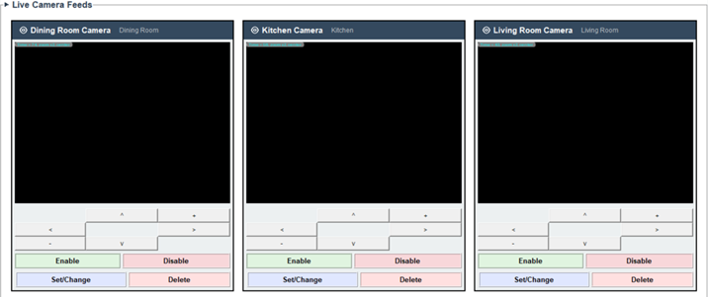
Tester | Onejune Lee
Test Date | 2025-12-05

Item | Excessive Camera Access Log Generation
Details | System automatically generates numerous 'camera view accessed' log entries on startup without user interaction. Clearing logs does not stop accumulation.
Reference | SRS: Use Case 'Display Specific camera view'; SDS: LogManager class, Event logging architecture
Reproduction Steps | 1. Start SafeHome application  2. Click Yellow Logs button  3. Observe excessive camera access logs  4. Click 'Clear Log' button  5. Wait 10 seconds  6. Observe logs continue accumulating
Screenshot | 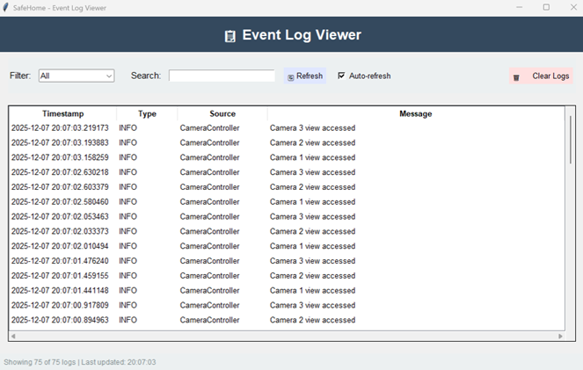
Tester | Onejune Lee
Test Date | 2025-12-06

Item | Event Log Filter Returns No Results
Details | Applying filter to event logs returns empty list even when matching events exist. Filter with 20+ camera events shows 0 results.
Reference | SRS: Use Case 'View intrusion log' implies filtering capability; SDS: LogManager class, filter functionality
Reproduction Steps | 1. Go to Logs by click yellow LOGS button in main page  2. Select filter criteria (e.g., 'Camera')  3. Observe: 0 results displayed despite visible matching events
Screenshot | 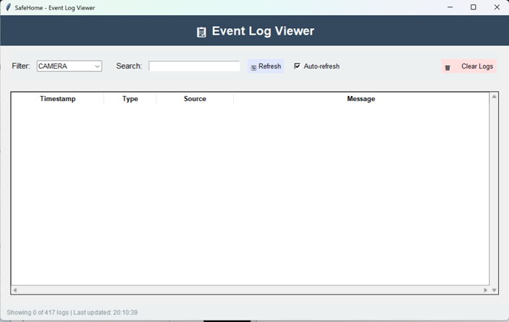
Tester | Onejune Lee
Test Date | 2025-12-07

Item | False Positive Password Deletion Confirmation
Details | System displays 'Password deleted successfully' message when deleting password from camera that never had password set.
Reference | SRS: Use Case 'Delete camera password' - Exception 10a; SDS: SafeHomeCamera class password management
Reproduction Steps | 1. Create new camera (no password set)  2. Navigate to Camera Management  3. Select camera  4. Click 'Delete Password'  5. Observe: Success message appears incorrectly
Screenshot | 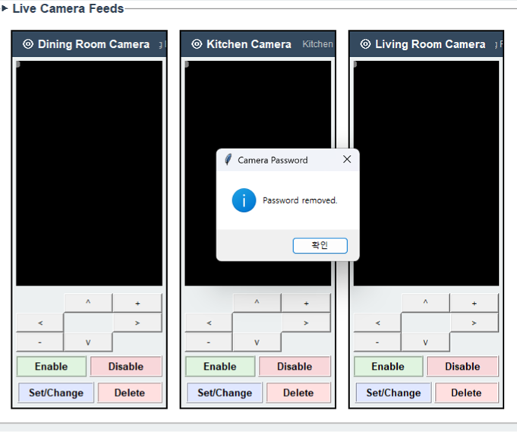
Tester | Onejune Lee
Test Date | 2025-12-04

Item | Sensor Alarm Delay Not Working
Details | Opening armed sensor (window/door) does not trigger alarm properly. Core security function non-operational. No delay timer working as specified.
Reference | SRS: Use Case 'Alarm condition encountered' - Steps 1-5; SDS: Alarm class, System class alarm handling, Sequence Diagram 'Alarm condition encountered'
Reproduction Steps | 1. Use Sensor Simulator tool  2. Select window/door sensor in armed zone  3. Send 'OPEN' signal to sensor  4. Go to system Log  5. System alert continues to generate & not delayed for 300 seconds
Screenshot | 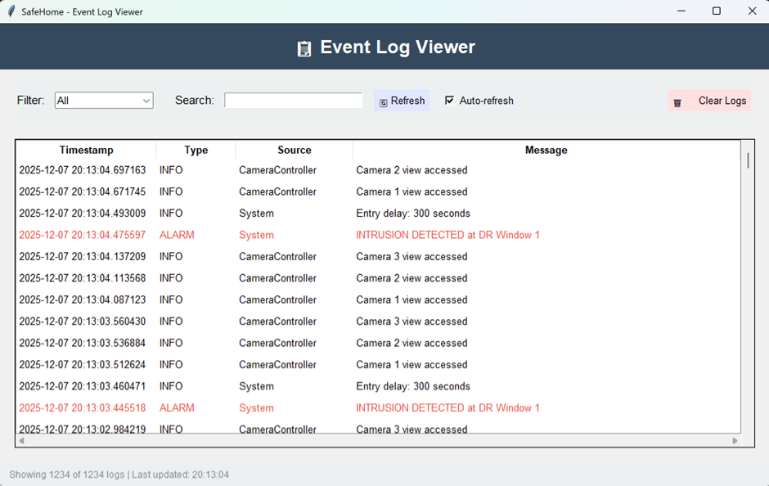
Tester | Onejune Lee
Test Date | 2025-12-05

Item | Master Password Change Not Persisting
Details | Changing master password shows success notification but new password not saved to database. User must continue using old password.
Reference | SRS: Use Case 'Change master password through control panel' - Step 9; SDS: LoginManager class, StorageManager class, Sequence Diagram 'Change master password through control panel'
Reproduction Steps | 1. Login with password '1234'  2. Navigate to Settings > Change Password  3. Enter new '5678'  4. Observe: Success notification shown  5. Logout  6. Attempt login with '5678' – FAILS  7. Login with '1234' - SUCCEEDS (change not saved)
Screenshot | No Image
Tester | Onejune Lee
Test Date | 2025-12-06

8. TEAM 9

Missing Implementations

Item | Control Panel Interface Missing
Details | Only web interface accessible. Control panel interface for local system access not implemented despite code imports suggesting existence.
Reference | SRS: Use Case 'Log onto the system through control panel', 'Arm/disarm system through control panel', 'Call monitoring service through control panel'; SDS: Architecture - External Communication Management, Control Panel Management section
Tester | Onejune Lee
Test Date | 2025-12-05

Item | Login Lockout Wait Time Not Displayed
Details | After 5 failed login attempts, account locks but no message displays remaining wait time or unlock time. User left guessing when retry is possible.
Reference | SRS: Use Case 'Log onto the system through web browser' - Exception 4a.2; SDS: LoginManager class, LoginInterface class
Tester | Onejune Lee
Test Date | 2025-12-04

Item | System Mode: Home (Stay) Missing
Details | Only Away and Stay modes available. 'Home' mode specified in SRS not implemented as distinct mode.
Reference | SRS: Use Case 'Arm/disarm system through control panel', 'Arm/disarm system through web browser' - system modes specification; SDS: SafeHomeMode class, System modes configuration
Tester | Onejune Lee
Test Date | 2025-12-05

Item | System Mode: Overnight Travel Missing
Details | Overnight Travel mode not available in mode selection. Cannot configure system for overnight absence scenario.
Reference | SRS: Use Case 'Arm/disarm system through web browser' - modes list; SDS: SafeHomeMode class, Configuration Manager modes
Tester | Onejune Lee
Test Date | 2025-12-06

Item | System Mode: Extended Travel Missing
Details | Extended Travel mode not implemented. Cannot set appropriate sensor configuration for extended absence.
Reference | SRS: Use Case 'Arm/disarm system through web browser' - modes list; SDS: SafeHomeMode class, mode definitions
Tester | Onejune Lee
Test Date | 2025-12-05

Item | Floor Plan Sensor Assignment Interface Missing
Details | Cannot select sensors by clicking on floor plan during safety zone creation. No graphical floor plan interaction for zone configuration.
Reference | SRS: Use Case 'Create new safety zone' - Step 2; SDS: FloorPlan class, DeviceIcon class
Tester | Onejune Lee
Test Date | 2025-12-04

Item | Only 3 of 10 Sensors Available
Details | System only allows assigning 3 sensors to zones. SRS floor plan specifies 10 sensors (6 window + 2 door + 2 motion). Missing 7 sensors.
Reference | Implementation Guide from TA; SRS: Floor plan sensor layout
Tester | Onejune Lee
Test Date | 2025-12-05

Item | Selected Sensors Not Visible in Safety Zone UI
Details | When configuring safety zones, no visual indicator shows which sensors are currently assigned. No checkmarks, highlights, or sensor list display.
Reference | SRS: Use Case 'Configure safety zone'; SDS: SafetyZone class, UI requirements for zone management
Tester | Onejune Lee
Test Date | 2025-12-06

Item | Safety Zone Selective Arm/Disarm Not Available
Details | Cannot arm or disarm individual safety zones. Only whole system arm/disarm supported. Zone-level granular control missing.
Reference | SRS: Use Case 'Arm/disarm safety zone selectively'; SDS: SafetyZone class, Sequence Diagram 'Arm/disarm safety zone selectively'
Tester | Onejune Lee
Test Date | 2025-12-06

Item | Display Specific Camera View Missing
Details | Cannot view individual camera feed. No camera viewing interface implemented at all.
Reference | SRS: Use Case 'Display Specific camera view'; SDS: CameraController class, SafeHomeCamera class, Sequence Diagram 'Display Specific camera view'
Tester | Onejune Lee
Test Date | 2025-12-04

Item | Camera Pan/Zoom Controls Missing
Details | No pan/zoom interface or controls available. Cannot control camera PTZ (Pan-Tilt-Zoom) functions.
Reference | SRS: Use Case 'Pan/Zoom specific camera view'; SDS: SafeHomeCamera class methods, Sequence Diagram 'Pan/Zoom specific camera view'
Tester | Onejune Lee
Test Date | 2025-12-05

Item | Set Camera Password Function Missing
Details | Cannot set password protection for individual cameras. Camera access control not available.
Reference | SRS: Use Case 'Set camera password'; SDS: SafeHomeCamera class password methods, Sequence Diagram 'Set camera password'
Tester | Onejune Lee
Test Date | 2025-12-06

Item | Delete Camera Password Function Missing
Details | Cannot remove password protection from cameras. No password deletion interface exists.
Reference | SRS: Use Case 'Delete camera password'; SDS: SafeHomeCamera class password methods, Sequence Diagram 'Delete camera password'
Tester | Onejune Lee
Test Date | 2025-12-05

Item | View Thumbnail Shots Missing
Details | Cannot view all cameras simultaneously in thumbnail view. Multi-camera overview not available.
Reference | SRS: Use Case 'View thumbnail Shots'; SDS: CameraController class, Sequence Diagram 'View thumbnail Shots'
Tester | Onejune Lee
Test Date | 2025-12-04

Item | Enable Camera Function Missing
Details | Cannot enable disabled cameras. No camera enable control in interface.
Reference | SRS: Use Case 'Enable camera'; SDS: SafeHomeCamera class enable/disable, Sequence Diagram 'Enable camera'
Tester | Onejune Lee
Test Date | 2025-12-05

Item | Disable Camera Function Missing
Details | Cannot disable active cameras. No camera disable control in interface.
Reference | SRS: Use Case 'Disable camera'; SDS: SafeHomeCamera class enable/disable, Sequence Diagram 'Disable camera'
Tester | Onejune Lee
Test Date | 2025-12-04

Item | Security Functions Misplaced on Surveillance Page
Details | Arm/Disarm buttons and Panic Alarm located on Surveillance page instead of Security page. Violates architectural separation.
Reference | SRS: Separate Security and Surveillance functions (Sections V.2 and V.3); SDS: Architecture diagram, Security subsystem vs Surveillance subsystem
Tester | Onejune Lee
Test Date | 2025-12-05

Item | Configuration Tab Mislabeled
Details | Configuration tab labeled inconsistently as 'configuration', 'intrusion log', and 'monitoring & intrusion log' across UI.
Reference | SRS: Use Case 'Configure system setting'; SDS: WebInterface class, Page hierarchy
Tester | Onejune Lee
Test Date | 2025-12-04

Bugs

Item | Homeowner User Not Found Error
Details | The given account in readme not working. Login fails with 'user not found' error.
Reference | SDS: LoginManager class, User initialization
Reproduction Steps | 1. Try login by using account in readme (homeowner, first123)  2. Observe 'user not found' error
Screenshot | 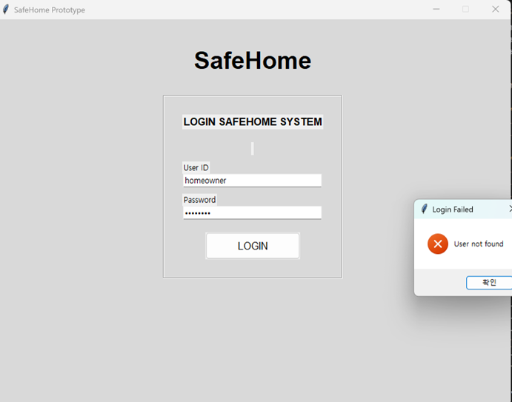  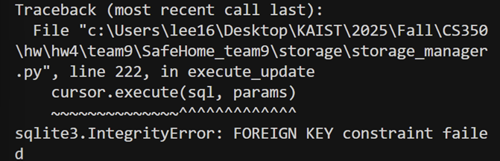
Tester | Onejune Lee
Test Date | 2025-12-07

Item | Authentication Failure on Surveillance Tab
Details | After successful web login, clicking Arm/Disarm on Surveillance tab throws 'login required' error. Session not maintained across tabs.
Reference | SRS: Use Case 'Arm/disarm system through web browser'; SDS: LoginManager class, WebInterface session management
Reproduction Steps | 1. Login to web interface with valid credentials  2. Verify dashboard displayed successfully  3. Navigate to Surveillance tab  4. Click 'Arm Stay' or 'Arm Away'  5. Observe: 'Login required' error appears
Screenshot | Due to database error, system not worked
Tester | Onejune Lee
Test Date | 2025-12-05

Item | Contradictory Armed Status Display
Details | Surveillance page shows 'System: Disarmed' at top while simultaneously displaying 'Armed Zones: All zones armed' in status panel.
Reference | SRS: System status display requirements; SDS: WebInterface class, System state synchronization
Reproduction Steps | 1. Login to web interface  2. Arm system to Away mode  3. Navigate to Surveillance tab  4. Observe top status area: 'System: Disarmed'  5. Scroll to zone status panel  6. Observe: 'Armed Zones: All zones armed' (contradiction)
Screenshot | Due to database error, system not worked
Tester | Onejune Lee
Test Date | 2025-12-05

Item | Configuration Settings Modification Blocked
Details | Attempting to modify system settings (delay time, passwords, phone numbers) triggers 'authentication required' warning despite active admin session.
Reference | SRS: Use Case 'Configure system setting'; SDS: ConfigurationManager class, SystemSettings class
Reproduction Steps | 1. Login with admin credentials  2. Navigate to Configuration tab  3. Modify any setting (e.g., delay time)  4. Click 'Save' or 'Update'  5. Observe: 'Authentication required' warning  6. Observe: Changes not saved
Screenshot | Due to database error, system not worked
Tester | Onejune Lee
Test Date | 2025-12-04

III. Who Did What
MinJun Kim
Identified functional bugs and missing implementations in Team 4 and Team 5 submissions.
Evaluated and assigned scores for Team 4 and Team 5 across Documentation, Implementation, and Testing categories according to the project’s scoring rubric and Excel format.
Refactored and normalized the scoring structure for all teams to ensure consistency and alignment with the updated evaluation criteria.
Jehyung Kim
Identified functional bugs and missing implementations in Team 2 and Team 3 submissions.
Evaluated and assigned scores for Team 2 and Team 3 across Documentation, Implementation, and Testing categories according to the project’s scoring rubric and Excel format.
Wrote the bug report document summarizing the detected issues and missing features.
Onejune Lee
Identified functional bugs and missing implementations in Team 8 and Team 9 submissions.
Evaluated and assigned scores for Team 8 and Team 9 across Documentation, Implementation, and Testing categories according to the project’s scoring rubric and Excel format.
refactored reproduction steps for all bugs.

Yunje Lee
Identified functional bugs and missing implementations in Team 6 and Team 7 submissions.
Evaluated and assigned scores for Team 6 and Team 7 across Documentation, Implementation, and Testing categories according to the project’s scoring rubric and Excel format.
Wrote the bug report document summarizing the detected issues and missing features.

